Practical 5

SQL queries to retrieveing data from tabkes using Pattern macthing and Sorting, ordering the data

***Query1. Write SQL query to list out the name of Product which have last charactor R.***

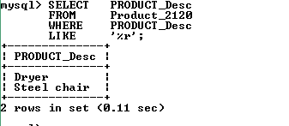

***Query2. Write SQL query to list out name of dependent whose relationship status end with “SE”***

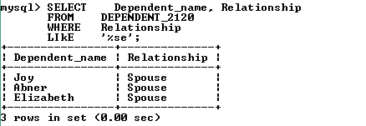

***Query3. Write SQL query to list out name and address of customer who brought the product with quantity greater than 80 and their country name start with Character “I”.***

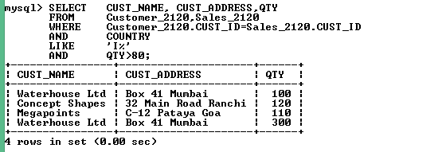

***Query4. Write SQL to list out name of employee whose First name contain a substring “SH”.***

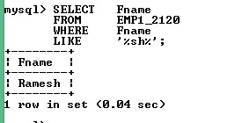

***Query5. Write SQL query to list out name of employee whose first name end with a substring “SH”.***

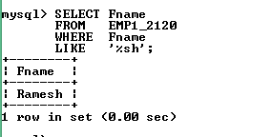

***Query6. Write SQL query to list out name of employee whose first name contain substring “SH” and have exactly two characters after the word “SH”.***

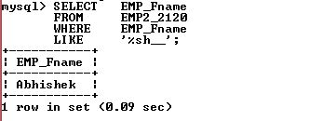

***Query7. Write SQL query to list out all the details of employee whose last name consist four characters.***

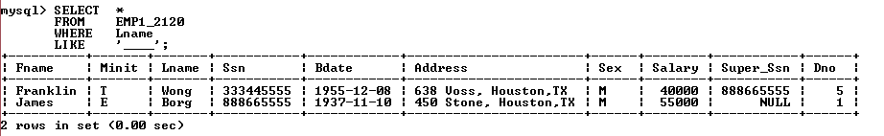

***Query8. Write SQL query to list out Project details according to Project location in ascending order.***

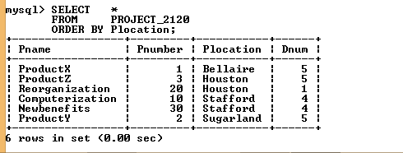

***Query9. Write SQL query to list out the name of employee and address according to their increasing salary.***

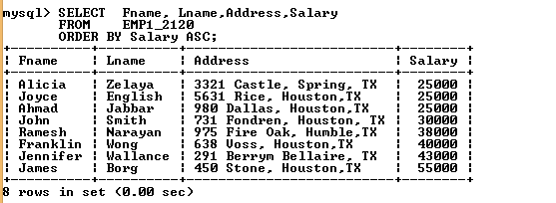

***Query10. Write SQL query to list out name, address of employee and dependent name ordered to their relationship status.***

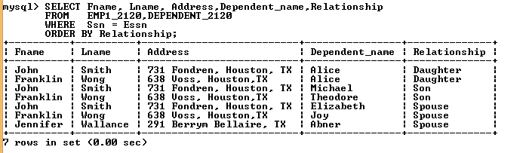

***Query11. Write SQL query to ordered the name of employee, project name, location, salary on the basis of their salary.***

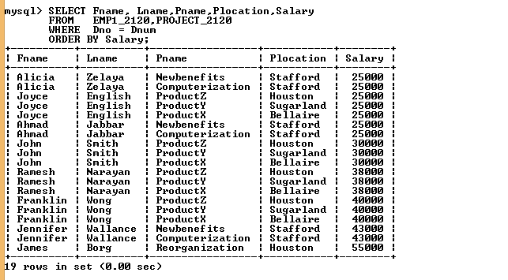

***Query12. Write SQL query to list out employee name whose name not end with character “N”.***

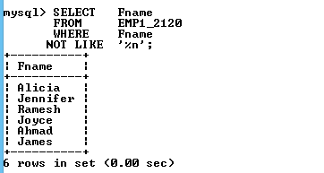

***Query13. Write SQL query to list out employee name, country those country name not start with “I”.***

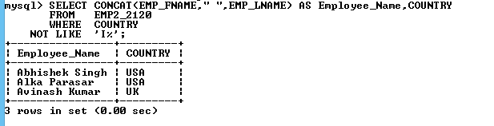

***Query14. Write SQL query to list out employee name, Salary, Country, Department where country starts with character ”I” and sorting their details in decreasing salary.***

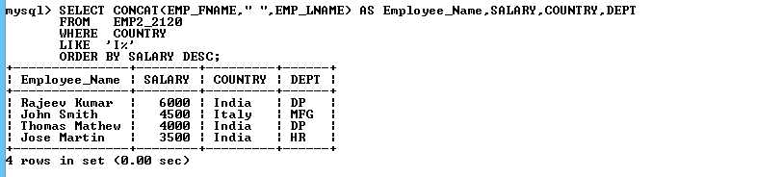

***Query15. Write SQL query to list out Product name, Id, Quantity and unit price of product which end with character “r” and Quantity in descending order.***

